1. Workout: 2 3

x 2

1. Given that A = {a, b, c, d, e} and B = {a, e, i, o, u}. Find the number of elements in the complement of set B.

1. Find the Lowest Common Factor (L.C.F) of 15 and 12.

1. Round off 48.875 to one decimal place.

1. What integer is represented by the arrow marked **x** on the number line below.

x

D:\CORNERSTONE 2018\all drawings others\number line 1.PNG

1. Express 0.45km2 to m2.

1. Given that 103n = 28 ten. Find the value of n.
2. Complete the table below

|  |  |  |
| --- | --- | --- |
| Number | _______ | 18 |
| Tally | **//// //// //** | _____ |

1. What angle is its complement.

1. Amoit was born in 24BC and died in 13AD. How old was she?

1. Express 0.1666… as a common fraction it its simplest form.

1. Amina sold all the milk in the jerrycan shown below using a 500ml cup.

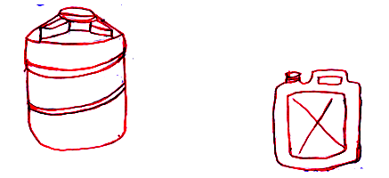How many full cups did she sell from the full jerrycan?

1. Simplify: 2(p+1) + 3 (p – 2).

1. Using a ruler, a pair of compasses and a sharp pencil only, construct an angle of 1050.

1. Yesterday was Monday. What day of the week will it be 25 days from now?

1. Write (3x102) + (4x100) + (8x10-1) + (6x10-2) in scientific notation.

1. Find the mean of 4, 3a, 6+2a and 2+3a.
2. The temperature on a mountain was -140C. If it dropped by 40C in 2 hours; Find the new temperature at the mountain.
3. Find the value of n in degree.

560

n

1. Solve;  - p **<** 2.

**SECTION B**

1. a) Simplify: 

b) Express  as a decimal fraction.

1. Omoda, Okello and Oketch are to appear at Nakawa Courts after every 12 days, 15 days and 30 days respectively.
2. If they first appeared to court on Thursday, on what day of the week are they expected to report together again?
3. How many times will Omoda have been to court by the time they report together again?

1. In Kikube village , 25 farmers grow Bananas (B) only, 2y grow Potatoes (P) only,

y + 4 farmers grow both crops while the farmers who do not grow any of the two crops are twice those that grow both crops.

1. Represent the information on a venn diagram

**∑ =**

n(p) n(B)

2y y+4 ___

___

1. If 20 farmers do not grow any of the two crops; find the value of y.
2. How many farmers grow only one type of crop?
3. Mulaato’s paddock farm measures 100m by 50m as shown below

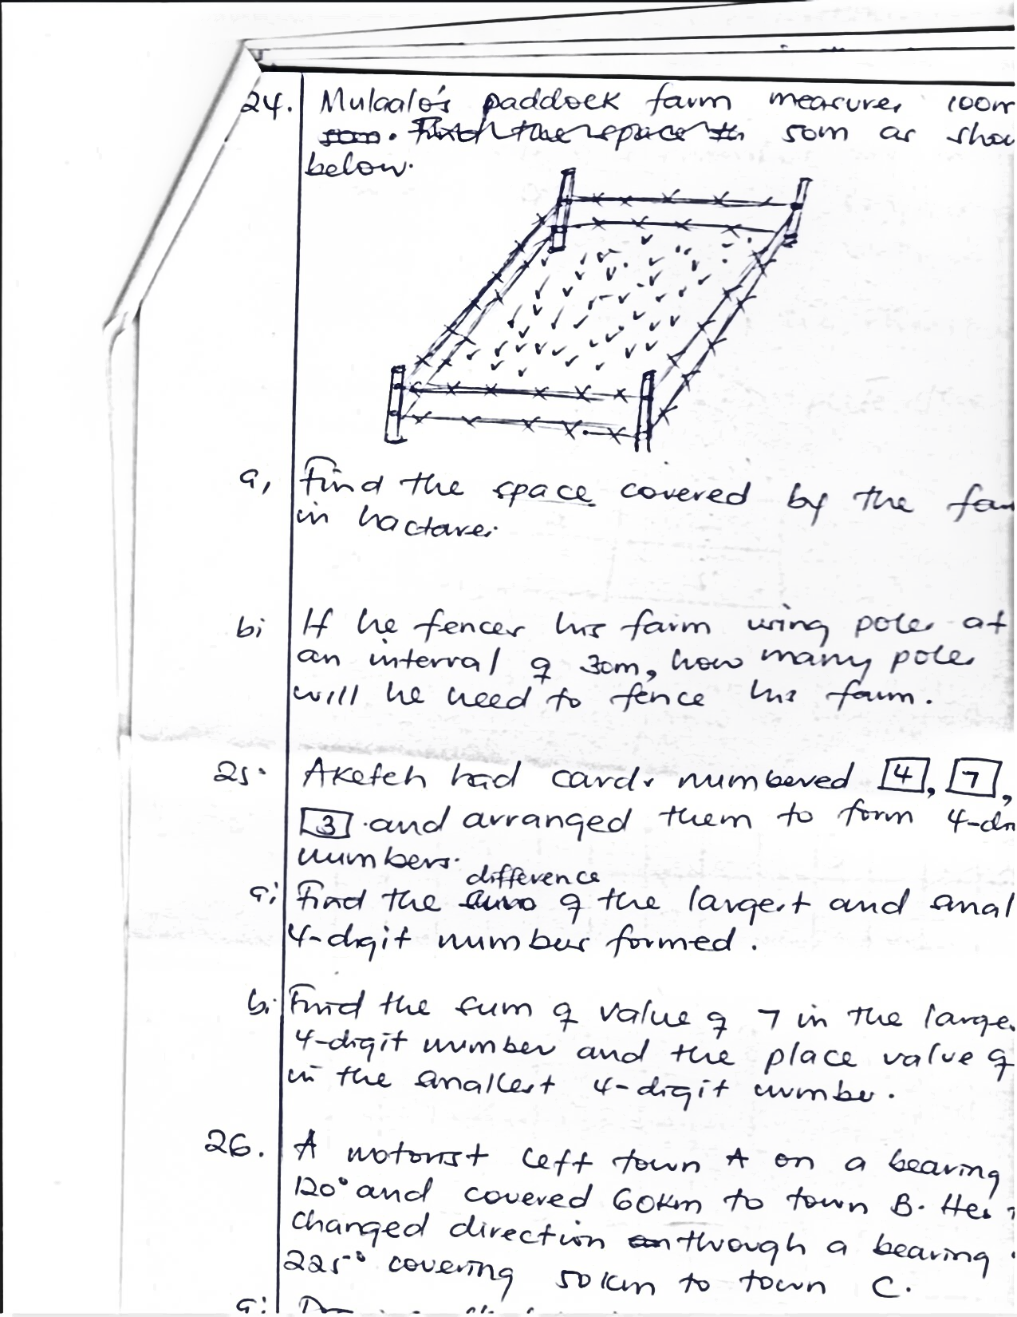

1. Find the space covered by the farm in hectare.

1. If he fences his farm using poles at an internal of 30m, how many poles will he need to fence his farm.
2. Aketch had cards numbered 4 , 7 , 0 and 3 and arranged them to form 4 – digit numbers.
3. Find the difference of the largest and smallest 4-digit numbers formed.

1. Find the sum of value of 7 in the largest 4- digit number and the place value of 0 in the smallest 4-digit number.

1. A motorist left town A on a bearing of 1200 and covered 60km to town B. He then changed direction through a bearing of 2250 covering 50km to town C.
2. Draw a sketch diagram to show the motorist’s journey.
3. Using a scale of Ian represents 10km, draw an accurate diagram to show the three towns.

1. Find the shortest distance between town A and C.
2. The diagonals of a rhombus are in the ratio 3:4 respectively. If the longer diagonal is 16cms
3. Find the shorter diagonal

1. Calculate the perimeter of the rhombus
2. a) On the grid below, plot these points C 9-2,3) D(1, 3) E(3, -1) and F (-2,-1)

**Y-axis**

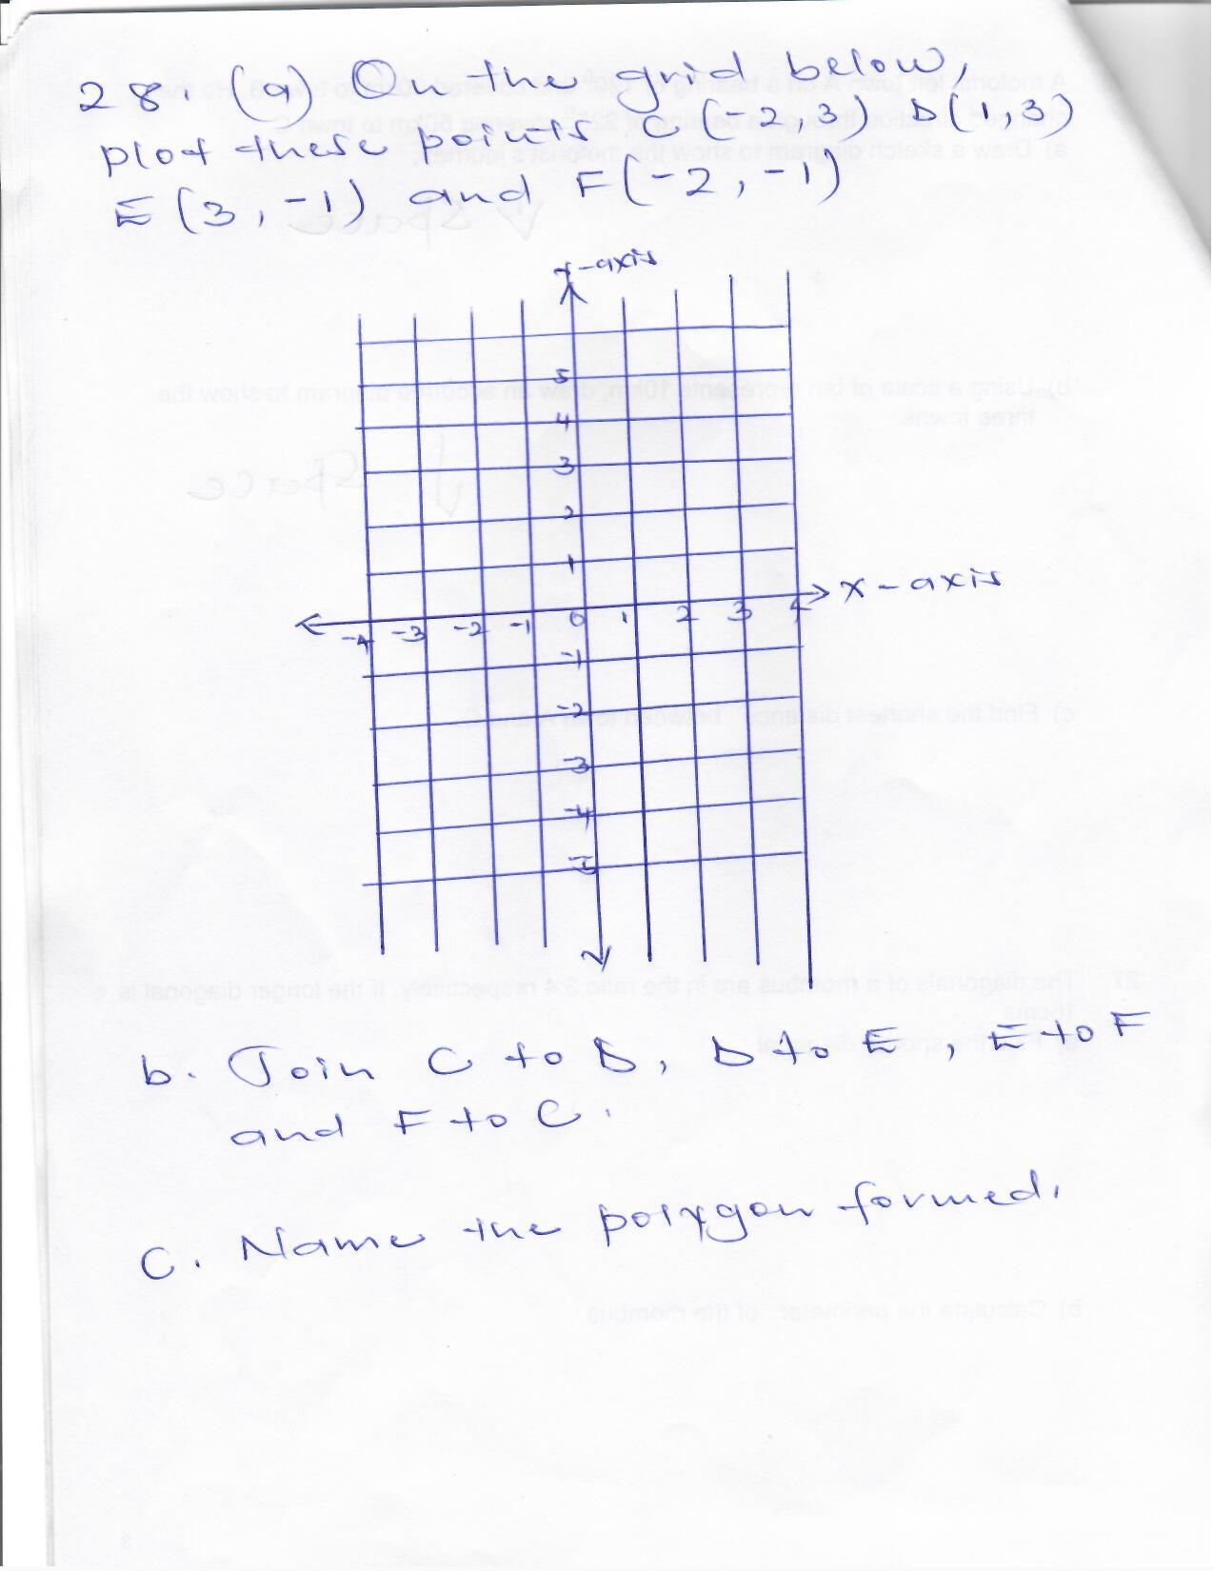

**X - axis**

b) Join C to D, D to E, E to F and F to C.

c) Name the polygon formed.

1. a) Solve;  = 

b) Dambwa was 5 years older than Carol ten years ago. If their total age is 35 years now, how old is Carol now?

1. Mukasa bought a radio at sh. 120,000 and sold it to Otima at a profit of 10%. Otima then sold the radio to Mutumba and made a loss of 20%. How much did Mutumba buy the radio?

1. Soap tablets were packed in a big box measuring 30cm by 20cm by 40cm.

**BOX SOAP TABLET**

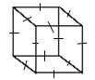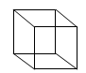

40cm

20cm 5cm

30cm

1. How many tablets were packed in the big box altogether?

1. If a shop keeper sells 3 layers of soap tablets from the box, how many tablets remained in the box?

1. The exterior angle of a regular polygon is 600 less than the interior angle. Name the polygon.

**END**